**ACKNOWLEDGEMENT**

I have taken efforts in this assignment. However, it would have not been possible without the kind support and help of many individuals. I would like to extend my sincere thanks to them. And I would like to extend my sincere gratitude to the Training and Placement Coordinator of the Lovely Professional University School of Computer Science and Engineering for granting me this opportunity.

I am both appreciative and fortunate to receive ongoing support, encouragement, and guidance from the teaching team at the School of Computer Science and Engineering. My time working with the **NAI DUNIYA NAI SOCH WELFARE FOUNDATION (NGO)** for community development provided me with a fantastic opportunity for learning and career growth.

I would like to express my gratitude towards our parents for their kind cooperation and encouragement which helped me in completing this assignment. My thanks and appreciation also go to the people who are directly or indirectly helped us out in developing the assignment.

## CERTIFICATE

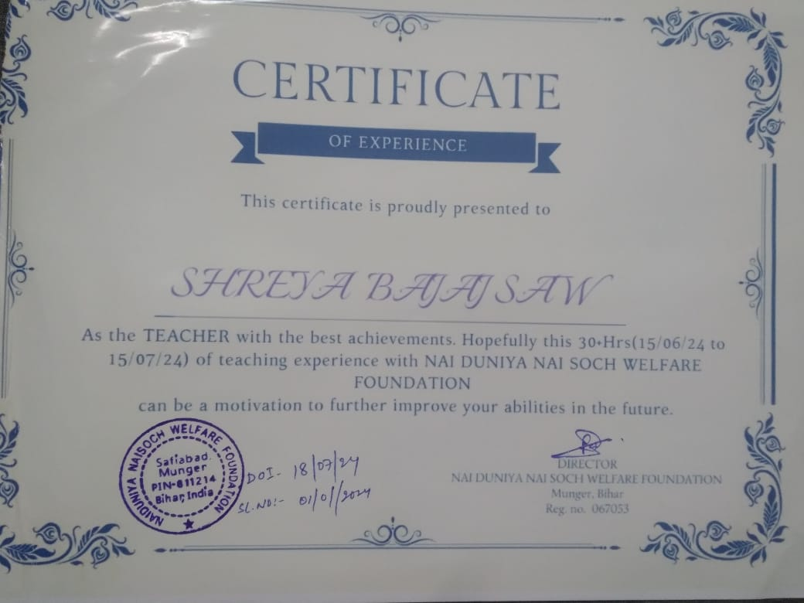

Link to the website:

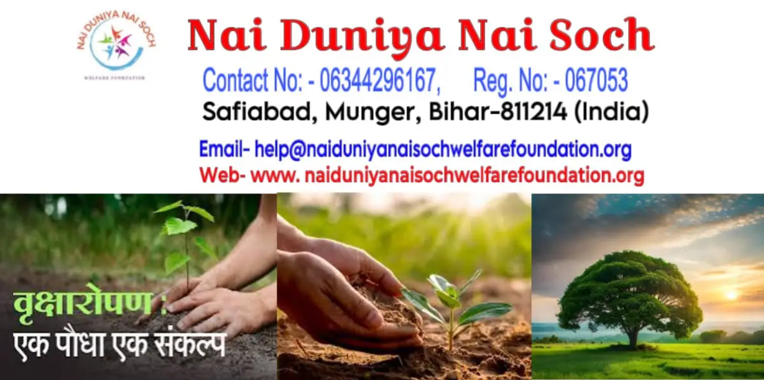

[https://naiduniyanaisochwelfarefoundation.org](https://naiduniyanaisochwelfarefoundation.org)

INTRODUCTION

I, Shreya Bajaj Saw, spent 30+ days at the NGO People’s Action for Social Service (Pass) as a part of my Community Development Project with Lovely Professional University’s Division of Student Welfare. My involvement with this NGO enriched my knowledge of lifestyle , culture , education and literacy. I had a total different experience which I documented in this report.

ABOUT **NAI DUNIYA NAI SOCH WELFARE FOUNDATON** :

NAI DUNIYA NAI SOCH WELFARE FOUNDATON is an Non-governmental Organization (NGO) based in Bihar. It is dedicated to uplifting women and children in rural areas is making significant strides by providing quality education and essential resources to those in need. This organization focuses on empowering women and children through educational programs that cater to their specific needs, offering both formal education and skill development opportunities.

In addition to providing access to schooling, the NGO ensures that students have all the necessary supplies, such as textbooks, stationery, and uniforms, to create an environment conducive to learning. Furthermore, they work closely with local communities to promote awareness about the importance of education, particularly for girls, and offer support services like counseling and health check-ups to address broader socio-economic challenges. By addressing both educational and basic needs, the NGO is fostering a brighter future for these communities, breaking the cycle of poverty, and empowering the next generation of women and children to achieve their full potential

The NGO is dedicated to addressing the critical needs of education and healthcare for women and children in rural communities. Recognizing the significant challenges faced by these groups, the mission focuses on promoting awareness and providing access to quality education and healthcare services. By empowering women and children through education and ensuring their health and well-being, the NGO aims to break the cycle of poverty and build stronger, self-sufficient communities.

**Problem Identification and Causes:**

**Education:**

* Limited access to quality education for children, particularly girls.
* High dropout rates due to economic constraints and cultural biases.
* Lack of infrastructure and educational resources in rural schools.

**Healthcare:**

* Poor awareness of basic health and hygiene practices among rural populations.
* Inadequate access to essential healthcare services and medical facilities.
* High prevalence of preventable diseases due to poor sanitation and lack of immunization.

**Causes of the Problems:**

* Insufficient funding and investment in rural education and healthcare infrastructure.
* Cultural norms and gender biases that discourage girls from attending school.
* Lack of awareness and education on health-related issues, including nutrition, hygiene, and disease prevention.
* Economic barriers preventing access to educational and healthcare resources.

**Objectives to be Achieved**

**Education:**

1. **Improving Access to Quality Education:**
   * Build and support schools in rural areas, ensuring they have the necessary infrastructure and resources.
   * Provide scholarships and financial incentives to encourage children, especially girls, to attend school.
   * Offer adult education programs to improve literacy rates among women who missed formal education opportunities.
2. **Promoting Gender Equality in Education:**
   * Advocate for equal access to education for girls by working with local leaders and communities.
   * Develop programs that encourage girls to pursue education and provide mentorship and support.
   * Implement awareness campaigns to change cultural attitudes towards girls’ education.
3. **Enhancing Educational Resources and Infrastructure:**
   * Supply rural schools with essential learning materials, such as textbooks, stationery, and digital tools.
   * Train teachers and provide professional development to improve the quality of education in rural schools.
   * Establish community libraries and learning centers to promote a culture of learning.

**Healthcare:**

1. **Raising Awareness on Health and Hygiene:**
   * Conduct community-based health education programs focusing on nutrition, hygiene, and preventive care.
   * Collaborate with local health workers to provide regular workshops and health camps in rural areas.
   * Develop and distribute informational materials in regional languages to educate communities about health and wellness.
2. **Improving Access to Healthcare Services:**
   * Establish mobile clinics and telehealth services to reach remote areas with limited access to healthcare facilities.
   * Provide free or subsidized medical care, including vaccinations and maternal health services, to underserved populations.
   * Partner with government agencies and other NGOs to enhance healthcare infrastructure in rural areas.
3. **Promoting Women's Health:**
   * Ensure access to reproductive health services, including family planning, prenatal care, and maternal health support.
   * Educate women on health issues, such as nutrition, breastfeeding, and disease prevention, through targeted programs.
   * Offer counseling and support services for women facing health challenges, including mental health support.

**Steps Taken to Achieve the Objectives**

**Education:**

1. **Building Educational Infrastructure:**
   * The NGO has collaborated with local communities to construct and renovate schools in rural areas, ensuring they have safe and conducive learning environments. It has also provided necessary furniture, learning materials, and technology to enhance the quality of education.
2. **Scholarship Programs:**
   * The NGO has launched scholarship programs to support children from economically disadvantaged families, enabling them to continue their education without financial burdens. Special emphasis is placed on encouraging girls to stay in school and pursue higher education.
3. **Community Engagement and Advocacy:**
   * Through community meetings and partnerships with local leaders, the NGO advocates for the importance of education, particularly for girls. It has also conducted awareness campaigns to change societal attitudes and eliminate barriers to education.

**Healthcare:**

1. **Health Education and Awareness Campaigns:**
   * The NGO has organized health education workshops and camps in rural communities to raise awareness about essential health practices, including hygiene, nutrition, and disease prevention. These programs have reached thousands of villagers, empowering them with knowledge to lead healthier lives.
2. **Mobile Clinics and Telehealth Services:**
   * To improve access to healthcare, the NGO has established mobile clinics that travel to remote villages, providing medical consultations, treatments, and vaccinations. Additionally, telehealth services have been introduced to connect rural patients with healthcare professionals.
3. **Partnerships for Improved Healthcare Services:**
   * The NGO works closely with local healthcare providers, government agencies, and other organizations to strengthen healthcare infrastructure and services in rural areas. It has successfully lobbied for increased funding and resources to improve healthcare delivery.

**Conclusion**

The NGO is committed to raising awareness and providing access to education and healthcare for women and children in rural areas. Through comprehensive programs and initiatives, it strives to empower these communities, improve their quality of life, and foster sustainable development. With continued support and collaboration, the NGO aims to create a brighter future for all, where every child has access to quality education and every woman has the right to health and well-being.

## GEO-TAGGED PICTURES

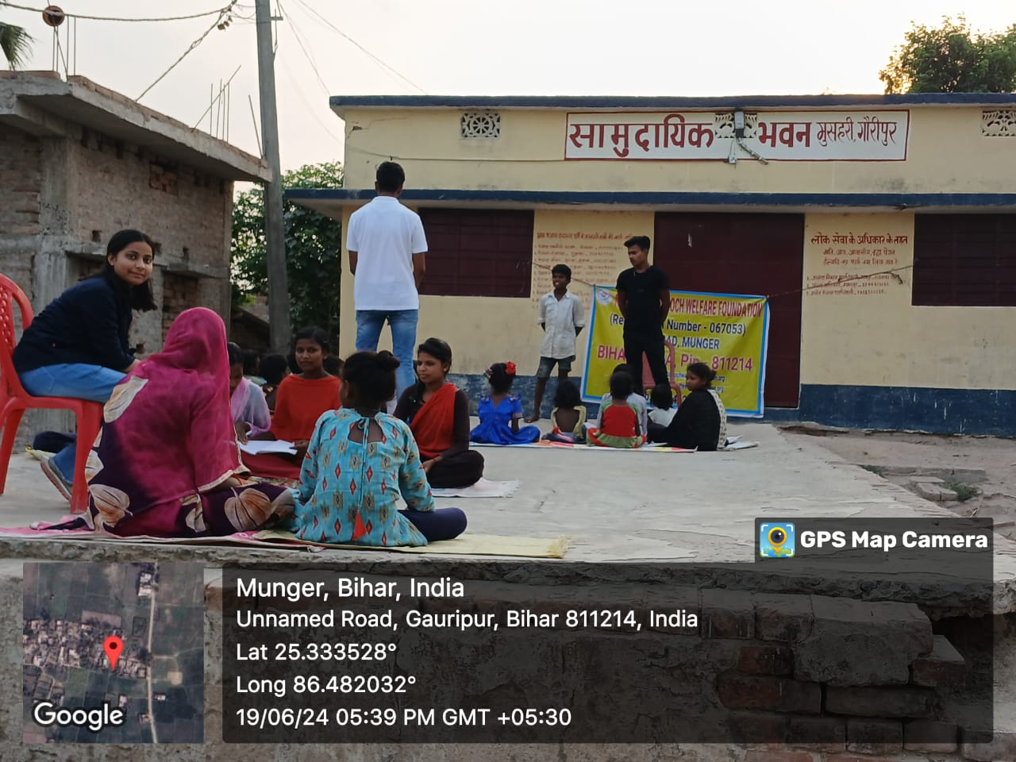

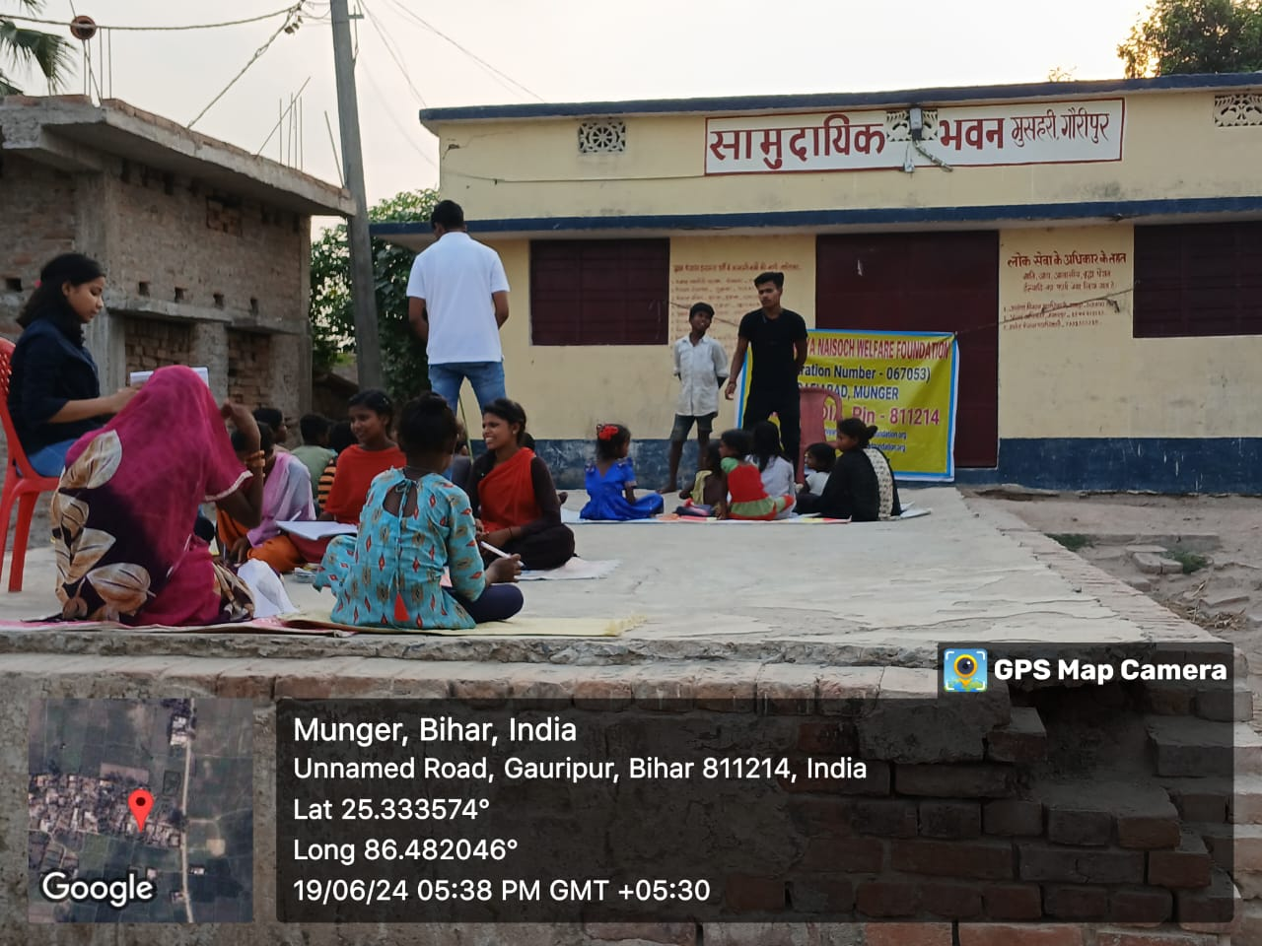

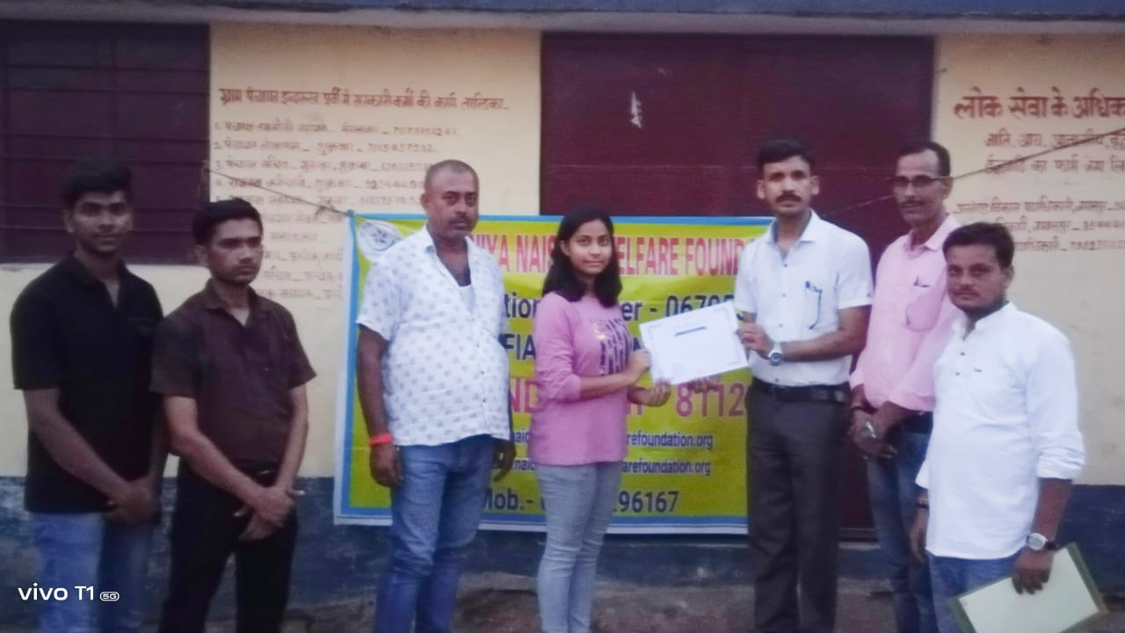

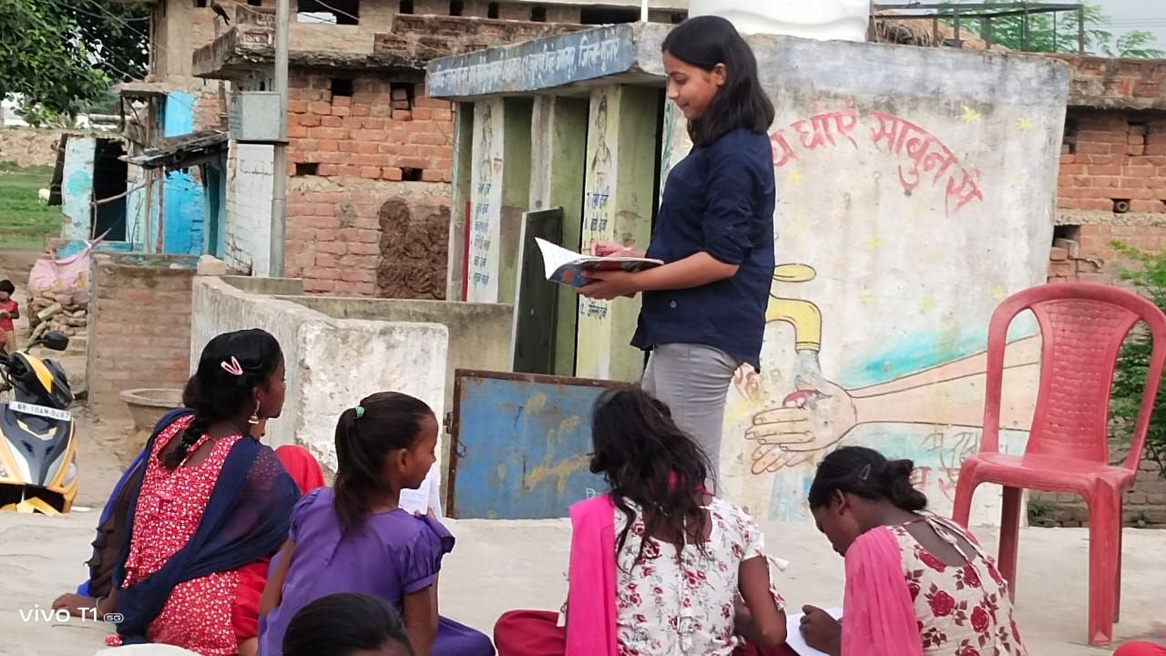 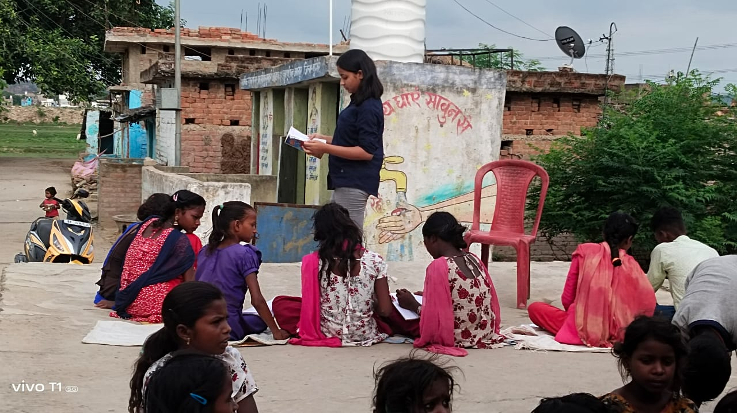

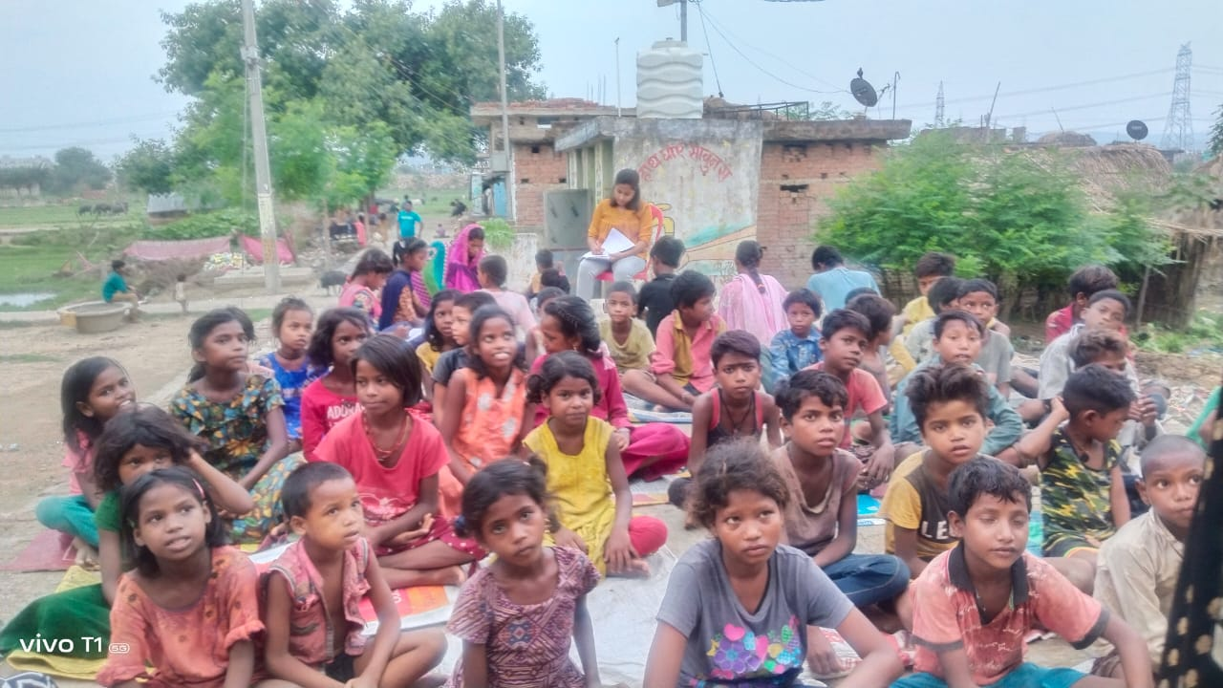 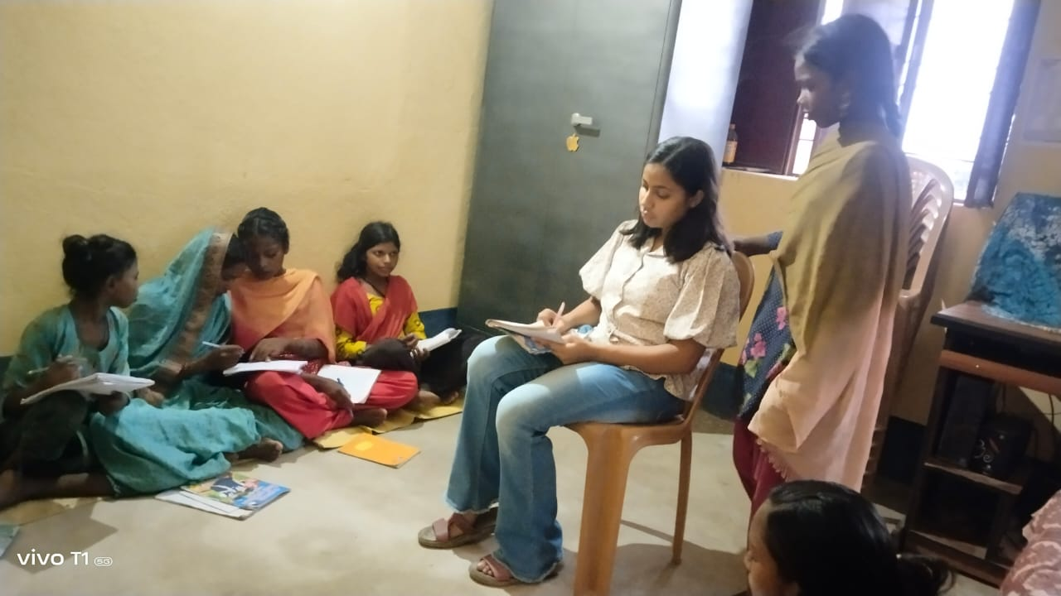

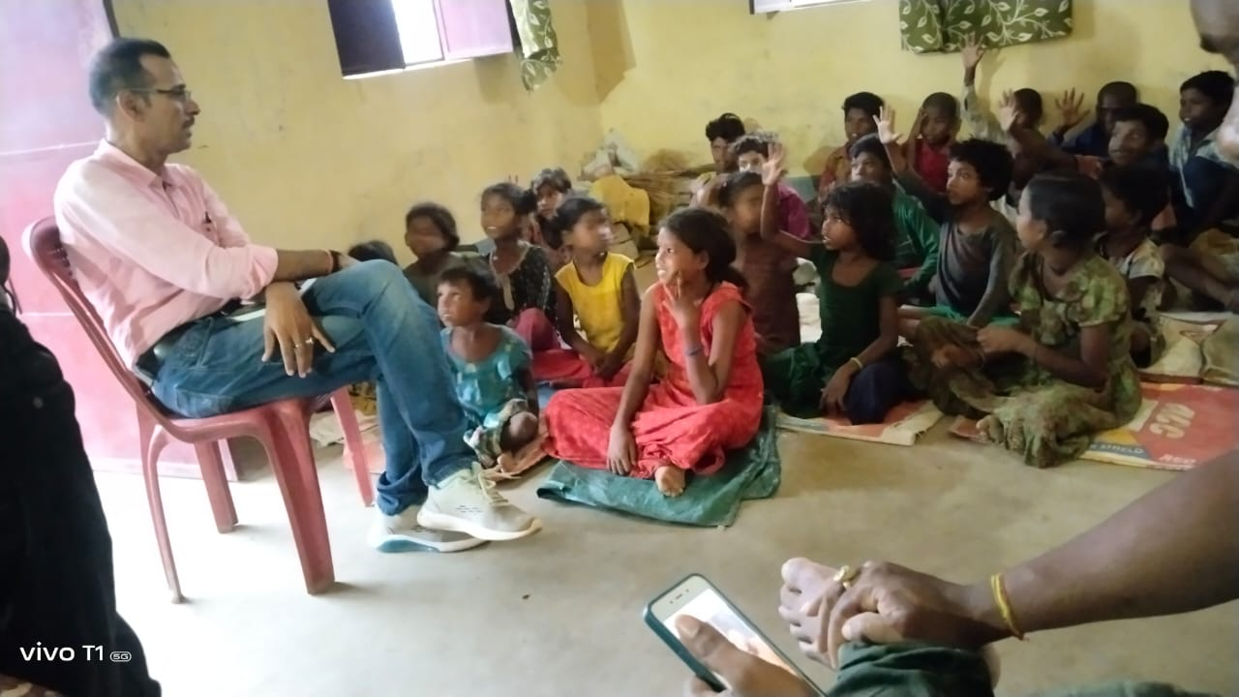 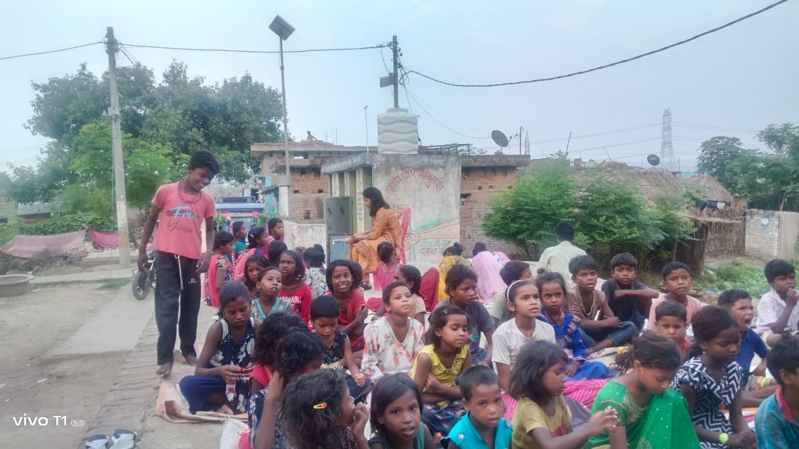

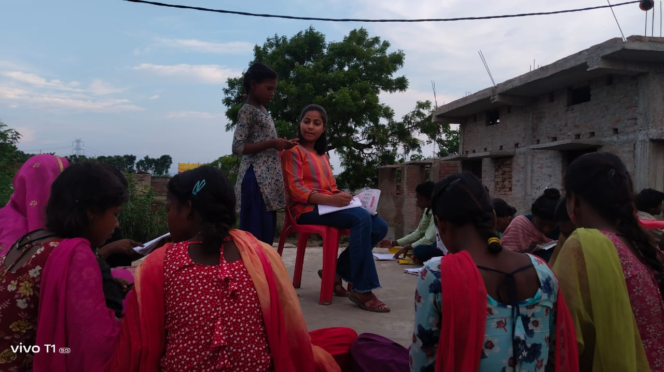



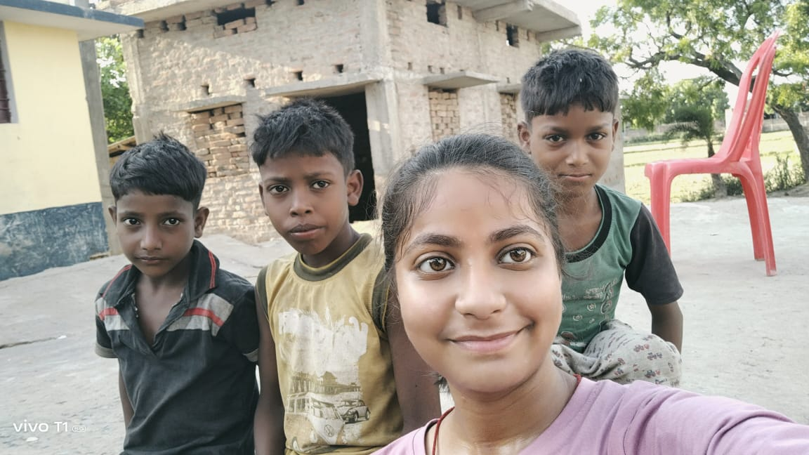

### 

### 

### 

This community development project, initiated by our university in collaboration with the NGO, has made significant progress in raising awareness about the importance of education and healthcare for women and children in rural areas. By addressing critical gaps in educational access and healthcare services, the project has empowered communities to recognize the value of education, particularly for girls, and the necessity of maintaining good health. Through strategic initiatives such as building schools, providing scholarships, organizing health camps, and conducting awareness campaigns, the project has fostered a sense of self-reliance and community spirit. Moving forward, continued efforts and partnerships will be essential to sustain these achievements and further enhance the well-being and opportunities for rural populations, ultimately contributing to a more equitable and educated society.